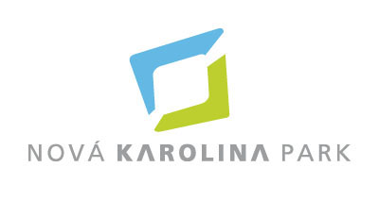

**PRESS RELEASE** Ostrava, 23 January 2019

**Nová Karolina Park has a new tenant – VERIZON**

**Verizon Czech s.r.o. has chosen the Nová Karolina Park office building in Ostrava as the headquarters for its team for the support of the global Verizon Enterprise Solutions. The company uses 2900 m2 on the 6th storey of the north and south parts of the building for its offices, relaxation spaces and other facilities. Nová Karolina Park has the last available 3700 m2 of office space and a retail unit with an area of 86 m2 on the ground floor.**

Nová Karolina Park is an architecturally unique project in the centre of Ostrava, which connects its historical area with the modern neighbourhood of Nová Karolina, which has arisen on the site of a former mine. The building has excellent traffic accessibility not only by mass transit, but also by car. Apart from the first-rate office spaces and modern technologies, this was one of the decisive arguments for companies that have chosen Nová Karolina Park as their seat. The wide variety of shops and services in the building and the surrounding area is also a considerable added value.

Verizon is one of the today’s largest telecommunication companies. The company’s main headquarters are located in the United States and it employs more than 150 000 people the world over. Each day the company connects millions of people, companies and communities from the entire world using its global computer networks and telecommunication technologies, so that it can fulfil its goal to “Give people the ability to do more”. The task for the Ostrava team is operations management, which means taking care of the technologies that help Verizon’s customers to do their business. That is the key role for Verizon in all the countries of the world and also for the quickly developing team in Ostrava.

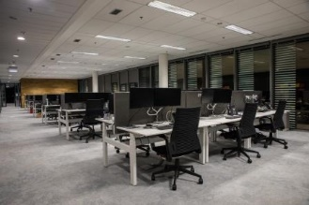

The new Verizon offices on the 5th storey of the Nová Karolina Park office building

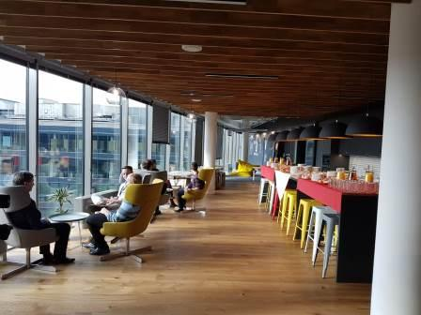

The new relaxation spaces of the Verizon offices in Nová Karolina Park

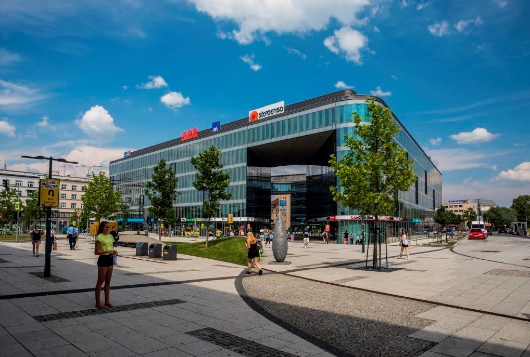

The Nová Karolina Park building

**ABOUT THE NOVÁ KAROLINA PARK PROJECT**

The **Nová Karolina Park** office building is sensitively located in a newly-urbanised area of Ostrava near Masarykovo náměstí and it forms a “gateway” from the historic core of the city. The developer of the project is a joint venture between [PASSERINVEST GROUP](http://www.passerinvest.cz/) and GEMO OLOMOUC. The project’s architectural design comes from the drawing boards of Vít Máslo and David R. Chisholm of CMC architects. The entire project is spread out over 32 hectares of space on six storeys and it offers almost 24,600 m2 of prime office space. This is supplemented on the ground floor with 3700 m2 of space suitable for shops, services and restaurants. There are 279 underground parking spaces meant for the users of the building. Nová Karolina Park is certified as a green building according to BREEAM (BRE Environmental Assessment Method). The British BREEAM certificate is a prestigious methodology for the certification of green buildings in Europe.

**PASSERINVEST GROUP**, a. s., is a purely Czech development and investment company, whose name is primarily connected with the realisation of the multifunctional **BB Centrum** complex in Prague 4 – Michle. The company, established by Radim Passer in 1991, built a very good reputation both on a local and international level with this, the most successful and extensive project of its kind in Central Europe. This is not only to the credit of the quality of the realised projects and the high level of the provided services, but also due to the sense of fair play, an accommodating relationship with the buildings’ tenants/users and responsibility to the society and the environment. **PASSERINVEST GROUP** also has other interesting development projects in its portfolio.

You can get more information and photographs in print quality from:

Kristýna Samková, Head of PR and Marketing Department

**PASSERINVEST GROUP, a.s.**

Tel.: (+420) 221 582 111

Mobile: (+420) 602 186 708

E-mail: [Kristyna.Samkova@Passerinvest.cz](mailto:Kristyna.Samkova@Passerinvest.cz)

www.passerinvest.cz, [www.bbcentrum.cz](http://www.bbcentrum.cz)

Marcela Štefcová

**Crest Communications a.s.**

Mobile: (+420) 731 613 669

E-mail: marcela.stefcova@crestcom.cz

[www.crestcom.cz](http://www.crestcom.cz)